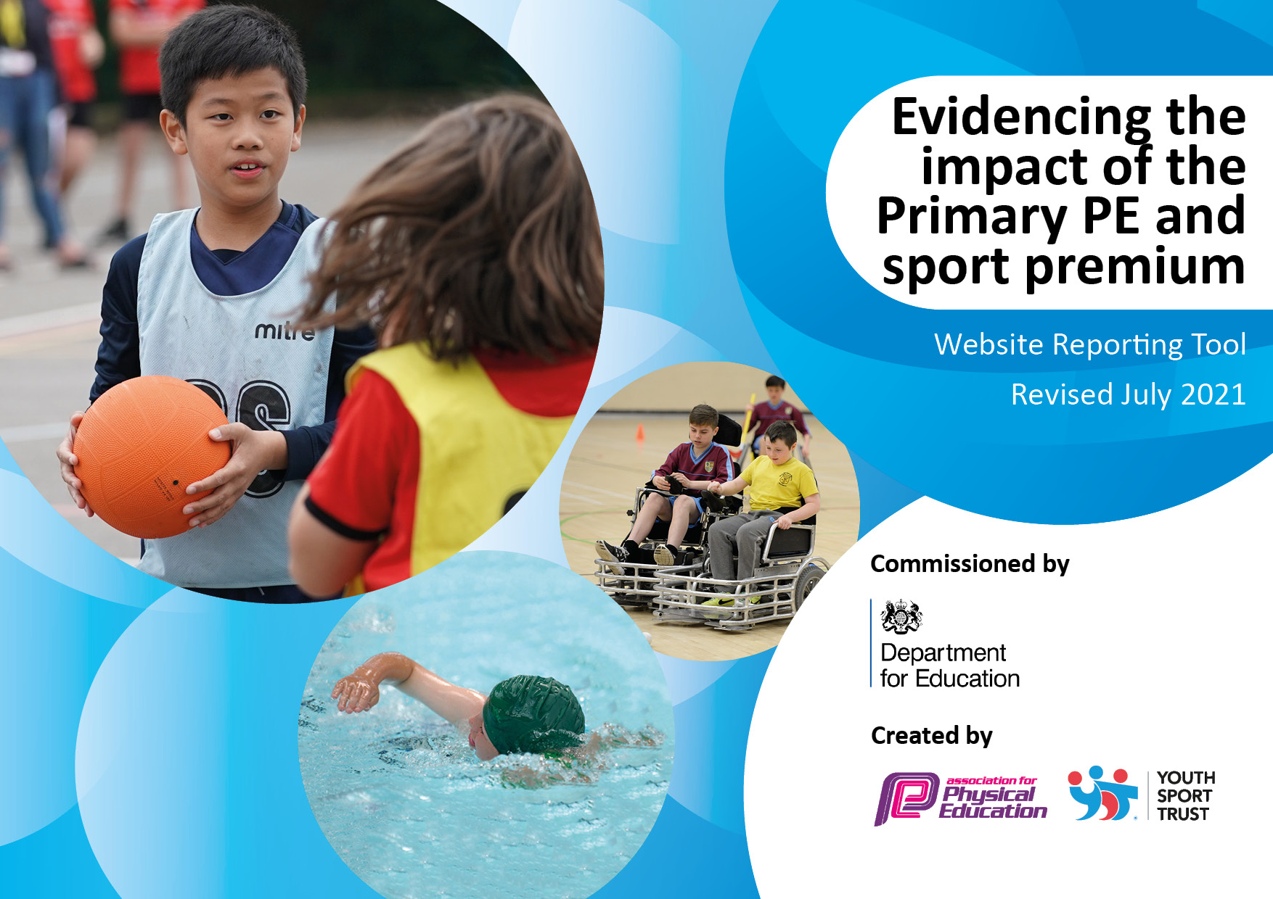
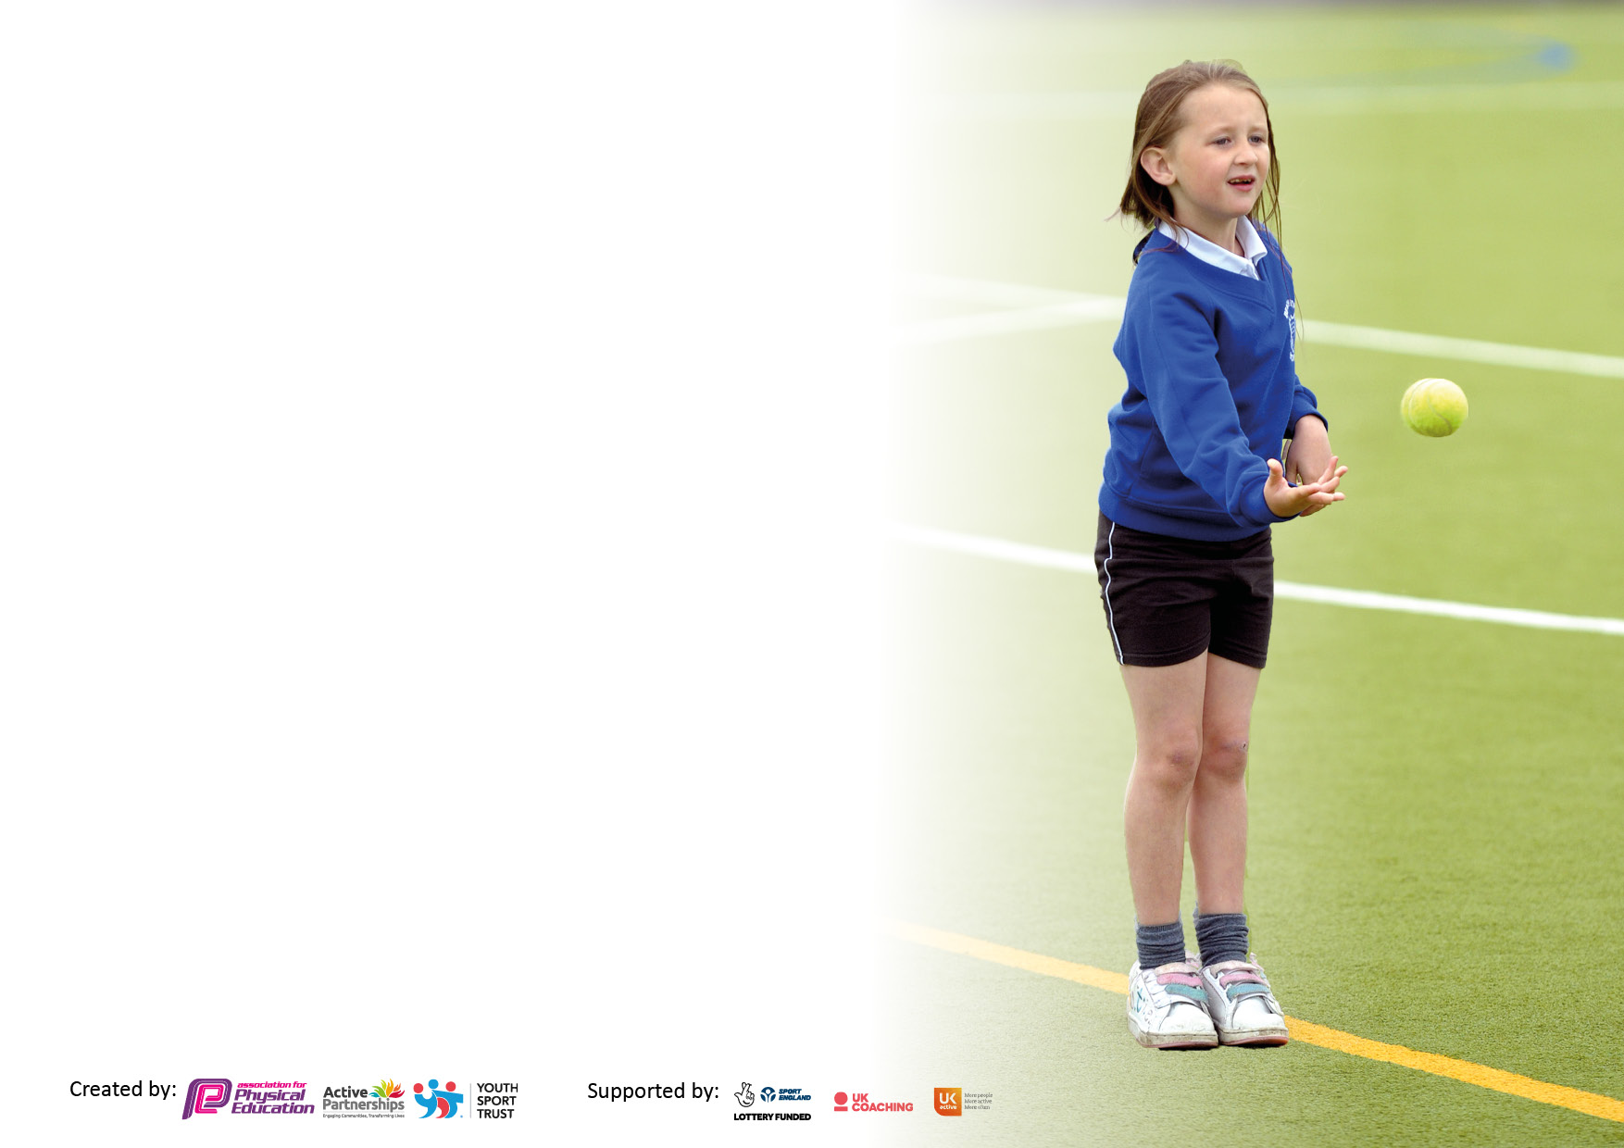

It is important that your grant is used effectively and based on school need. The Education Inspection Framework makes clear there will be a focus on ‘whether leaders and those responsible for governors all understand their respective roles and perform these in a way that enhances the effectiveness of the school’.

Under the Quality of Education Ofsted inspectors consider:
Intent - Curriculum design, coverage and appropriateness
Implementation - Curriculum delivery, Teaching (pedagogy) and Assessment
Impact - Attainment and progress

To assist schools with common transferable language this template has been developed to utilise the same three headings which should make your plans easily transferable between working documents.

Schools must use the funding to make additional and sustainable improvements to the quality of Physical Education, School Sport and Physical Activity (PESSPA) they offer. This means that you should use the Primary PE and sport premium to:

- Develop or add to the PESSPA activities that your school already offer
- Build capacity and capability within the school to ensure that improvements made now will benefit pupils joining the school in future years
- The Primary PE and sport premium should not be used to fund capital spend projects; the school’s budget should fund these.

Pleasevisitgov.ukfortherevisedDfEguidanceincludingthe5keyindicatorsacrosswhichschoolsshoulddemonstrate animprovement.Thisdocumentwillhelpyoutoreviewyourprovisionandtoreportyourspend.DfEencouragesschools to use this template as an effective way of meeting the reporting requirements of the Primary PE and sport premium.

We recommend you start by reflecting on the impact of current provision and reviewing the previous spend.

Schools are required to publish details of how they spend this funding, including any under-spend from 2019/2020, as well as on the impact it has on pupils’ PE and sport participation and attainment. All funding must be spent by 31st July 2022.

We recommend regularly updating the table and publishing it on your website throughout the year. This evidences your ongoing self-evaluation of how you are using the funding to secure maximum, sustainable impact. Final copy must be posted on your website by the end of the academic year and no later than the 31st July 2021. To see an example of how to complete the table please click HERE.

Details with regard to funding
Please complete the table below.

Total amount carried over from 2019/20 | £0
Total amount allocated for 2020/21 | £17,600
How much (if any) do you intend to carry over from this total fund into 2021/22? | £12,000
Total amount allocated for 2021/22 | £17,600
Total amount of funding for 2021/22. To be spent and reported on by 31st July 2022. | £29787.00
Swimming Data
Please report on your Swimming Data below.

Meeting national curriculum requirements for swimming and water safety.  N.B. Complete this section to your best ability. For example you might have practised safe self-rescue techniques on dry land which you can then transfer to the pool when school swimming restarts.  Due to exceptional circumstances priority should be given to ensuring that pupils can perform safe self rescue even if they do not fully meet the first two requirements of the NC programme of study | 75%
What percentage of your current Year 6 cohort swim competently, confidently and proficiently over a distance of at least 25 metres?  N.B. Even though your pupils may swim in another year please report on their attainment on leaving primary school at the end of the summer term 2020.  Please see note above | 79%
What percentage of your current Year 6 cohort use a range of strokes effectively [for example, front crawl, backstroke and breaststroke]?  Please see note above | 78%
What percentage of your current Year 6 cohort perform safe self-rescue in different water-based situations? | 74%
Schools can choose to use the Primary PE and sport premium to provide additional provision for swimming but this must be for activity over and above the national curriculum requirements. Have you used it in this way? | No

Action Plan and Budget Tracking
Capture your intended annual spend against the 5 key indicators. Clarify the success criteria and evidence of impact that you intend to measure to evaluate for pupils today and for the future.

Academic Year: 2020/21 | Total fund allocated: | Date Updated:
Key indicator 1: The engagement of all pupils in regular physical activity – Chief Medical Officers guidelines recommend that primary school pupils undertake at least 30 minutes of physical activity a day in school |  |  |  | Percentage of total allocation:
 |  |  |  | 29%
Intent | Implementation |  | Impact
Your school focus should be clear what you want the pupils to know and be able to do and about  what they need to learn and to  consolidate through practice: | Make sure your actions to achieve are linked to your intentions: | Funding allocated: | Evidence of impact: what do pupils now know and what can they now do? What has changed?: | Sustainability and suggested next steps:
Children CPD – Play leaders: Progressive sports | Year 5 and 6 will receive training to act as playground leaders during lunch times.  They will work with every year group in the school to play team activities and games or set independent challenges. | £175 | The year 5/6s enjoyed the CDP session. The whole school have benefitted as they now have active opportunities at lunch.
Breakfast/ Before school club – providing an assistant. | This will give children the opportunity to be physically active before school starts. | £4500 | Children have been given the opportunity to try new sports and participate in sport to develop fitness, sports specific knowledge of skills and tactics, teamwork, leadership etc. The children are awake, fuelled and ready for the start of the day.  Teachers have commented how much better the behaviour of these children is.
Sensory diet equipment | Children who have been identified will receive an active 5 minutes on the hour in the mornings around a range of activities to burn excess energy. | £100 | This has help the identified children greatly, causing them to be more focused and relaxed in the classroom setting and engage in the lesson better to produce a higher quality of work.
JumpStartJonny – 1 year subscription | This will enable the students to have active breaks between lessons or to allow the children to continue being active during wet breaks. | £229 | Children are active for an extra period of time per day.  SEN children are more focused in the class as they have ‘released energy and build up’.
Reception equipment | To give the students active learning opportunities to develop their core strength, coordination and stamina. | £2000
Balance bikes and helmets– reception | To improve children’s agility, balance, coordination, fine motor skills, core strength etc. | £750 | Children are more active and have a stronger core.  They understand how to be safe when on their bikes.
3x 40 minute Maths on the move sessions. | Helping a range of children to access maths through physical games and activities. Delivered by Progressive Sports | £1320 | Children enjoyed the opportunity to be active and learn in a different environment. The booklets the children worked through showed evidence of improvements in their learning.
Key indicator 2: The profile of PESSPA being raised across the school as a tool for whole school improvement |  |  |  | Percentage of total allocation:
 |  |  |  | 17%
Intent | Implementation |  | Impact
Your school focus should be clear what you want the pupils to know and be able to do and about  what they need to learn and to  consolidate through practice: | Make sure your actions to achieve are linked to your intentions: | Funding allocated: | Evidence of impact: what do pupils now know and what can they now do? What has changed?: | Sustainability and suggested next steps:
Smartkit PE Tops Reception | The children have been assigned to family teams to participate in in-house competitions. This will promote team skills such as organisation, teamwork and communication. | £364.50 | Children feel apart of a team.  Teams sports days
Sports Safe UK | Repair equipment in the hall for more active minutes and more children to be involved in PE lessons. | £1000 | Equipment, the hall, the field and playground are checked for safety.  Less fire aid incidents
Sports Day | To provide children with stickers and prizes for competing in the sporting event. This will motivate and enthuse the children | £300 | Children and parents were involved in a celebration of sport.
P.E/ sports equipment | More active minutes and more children involved in PE lessons (great ratio of equipment to students), due to a wider range of new equipment. | £3250 | Wide range of equipment is available for different abilities and ages for P.E, Lunch and afterschool club.

Key indicator 3: Increased confidence, knowledge and skills of all staff in teaching PE and sport |  |  |  | Percentage of total allocation:
 |  |  |  | 53%
Intent | Implementation |  | Impact
Your school focus should be clear | Make sure your actions to | Funding | Evidence of impact: what do | Sustainability and suggested
what you want the pupils to know | achieve are linked to your | allocated: | pupils now know and what | next steps:
and be able to do and about | intentions: |  | can they now do? What has
what they need to learn and to |  |  | changed?:
consolidate through practice:
Lunch time supervisor CPD – Progressive Sports | The lunch time supervisors will receive training to oversee and support the year 5 and 6 playground leaders. | £350 | Lunch time supervisors understand their roles and responsibilities better. (behaviour management, expectations, health and safety, first aid).  There have been less first aid incidents since the training due to the management at lunch.
Safe practice: in physical education, school sport and physical activity | To ensure lessons will follow the national guidance, legal practice etc, to a high quality. | £45 | Reduced first aid incidents.
P.E Passport | To support the staff to deliver high quality physical education. | £699 | The children have received higher quality lessons across a range of sports. The staff feel more comfortable in delivering the lessons as they have a structured plan to follow.
Training and resources for all members of staff to deliver and use the P.E Passport. | To deliver high quality physical education and evidence the progression of the children (data) and the performance in the P.E lessons. | £2500 | The children have received higher quality lessons across a range of sports. The staff feel more comfortable in delivering the lessons as they have a structured plan to follow.  The has monitored the delivery of P.E across the school closer.
Team teach – Socatots and Tenniswhizz in reception. Delivered by Progressive Sports | Staff to be uplevelled in the delivery of P.E and activities in reception | £540 | Active children and more confident Reception staff.
Team teach – Swimming teacher work with the ECT teacher and the year 6 teacher. | Year 5 and 6 teachers to feel more comfortable delivering swimming sessions. | £206 | The children will continue to receive a higher quality swimming lessons going forward.
Accelerate learning services 1-1 In depth package | Working 1-1 with a P.E specialist to plan the delivery of P.E within the school. | £3950 | Support has advised on areas to improve within the school: resources, active minutes, programmes which will influence the long term plan of P.E.
Accelerate learning services Quality mark package for 2022/2023 |  | £950
Supply to release sports coordinator. | To release the sports coordinator to attend courses or competitions. | £767
 |  |  |  | Percentage of total allocation:
Intent | Implementation |  | Impact
Your school focus should be clear | Make sure your actions to | Funding | Evidence of impact: what do | Sustainability and suggested
what you want the pupils to know | achieve are linked to your | allocated: | pupils now know and what | next steps:
and be able to do and about | intentions: |  | can they now do? What has
what they need to learn and to |  |  | changed?:
consolidate through practice:
After school clubs – Sports coach: Progressive Sports | To provide children with the opportunity to participate in a wide range of sports. Year 3 and 4 on Mondays, year 5 and 6 on Tuesdays and reception, year 1 and year 2 on Thursdays. | £3950 | Children have been given the opportunity to try new sports and participate in sport to develop fitness, sports specific knowledge of skills and tactics, teamwork, leadership etc. They have taken many of these skills forward in other aspects of school.
Additional achievements:  Wider sports equipment – breakfast club/ lunch time/ after school club/ enrichment. | The children will be involved a range of different sports and activities throughout break times and enrichments due to a wider range of new equipment. | £1000 | The children have tried new sports and activities.  Some have started going to local clubs due to the experience they have had a school.
In school competitions | The children will compete within their family (dragons, phoenix, griffin, unicorn). Prizes, certificates and trophies will be given out to enthuse and motivate the children. | £500 | The children enjoyed competing against each other at a range of competitions throughout the year. The year 6 leavers football tournament was a great success and children thoroughly enjoyed the opportunity to play sport for one last time together.
Enrichment day – Progressive sports (whole school) | To provide the children with wider sporting experience relating to an up coming major competition (Commonwealth). | £350 | Children enjoyed the event and received positive feedback from the parents too. Children are looking forward to watching a summer of sports at the commonwealth.

Key indicator 5: Increased participation in competitive sport |  |  |  | Percentage of total allocation:
 |  |  |  | >1%
Intent | Implementation |  | Impact
Your school focus should be clear | Make sure your actions to | Funding | Evidence of impact: what do | Sustainability and suggested
what you want the pupils to know | achieve are linked to your | allocated: | pupils now know and what | next steps:
and be able to do and about | intentions: |  | can they now do? What has
what they need to learn and to |  |  | changed?
consolidate through practice:
The school will host a year 6 leavers competition. Other schools will be invited to join the competition. This will be ran by Progressive Sports |  | £0
The school will continue to compete in the Burntwood and Lichfield schools competitions organised by J.Austin. |  | £0 | Children of a range of abilities were able to represent the school in a range of sports. Many of these sports the children hadn’t experienced previously.  The children were given responsibilities before and after the competitions (equipment, kits, writing a report, presenting to the school during a school assembly). | :
School sports tops | Children will be proud to represent the school in new sports tops for cricket and athletics events. | £250 | Children love the kit and take great pride in wearing it. They feel apart of the team when representing the school at interschool competitions.

Signed off by
Head Teacher:
Date:
Subject Leader:
Date:
Governor:
Date:

